**Practical 1**

**Aim: Basics of Python**

1. **Write a program to calculate area and perimeter of the square.**

**Code:**

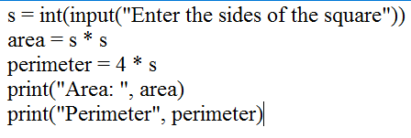

**Output:**

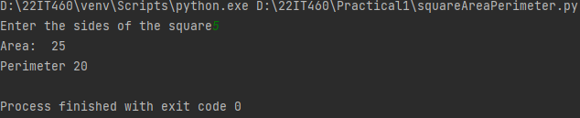

1. **Write a program to swap the value of two variables.**

**Code:**

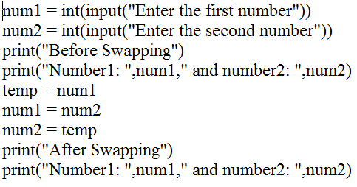

**Output:**

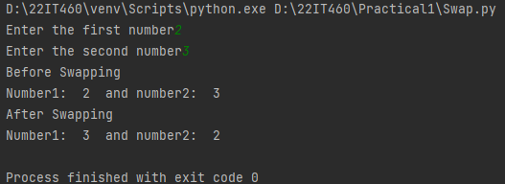

1. **Write a program to calculate simple interest.**

**Code:**

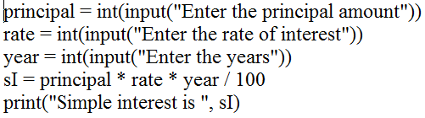

**Output:**

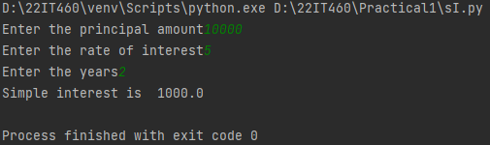

1. **Write a program to convert days into month and days.**

**Code:**

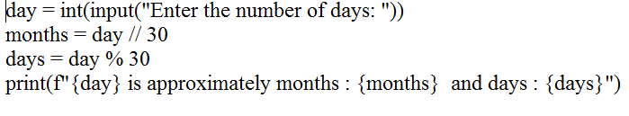

**Output:**

